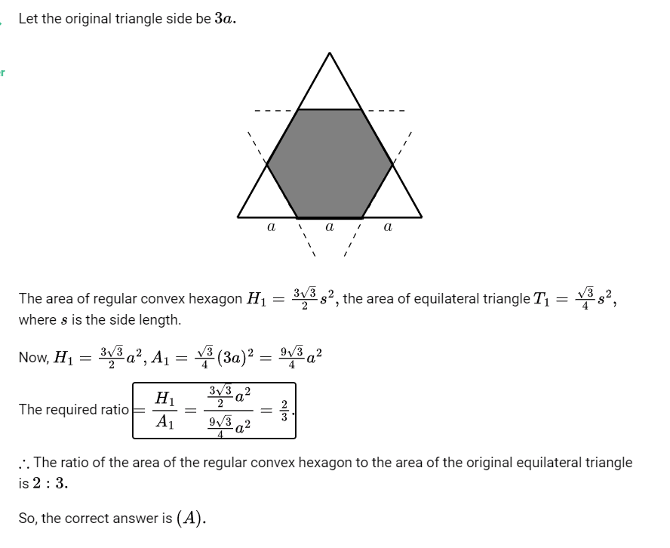

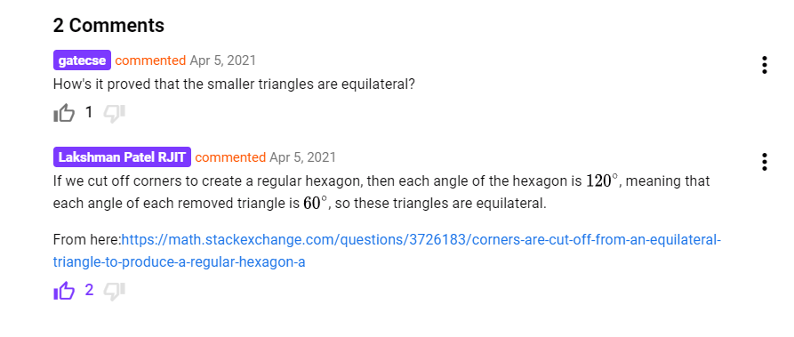

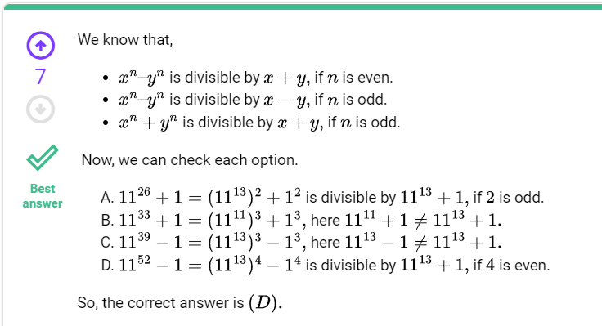

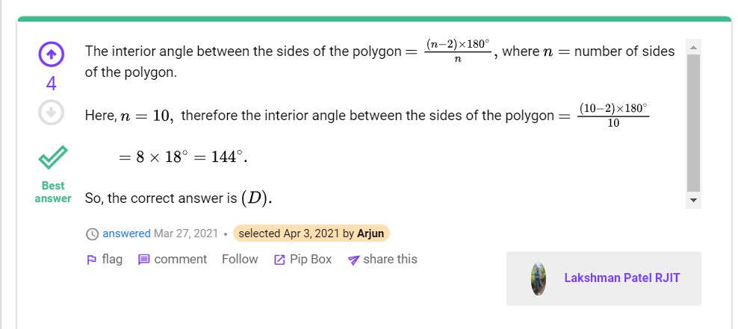

[Quantitative Aptitude: GATE2011 GG: GA-7 (gateoverflow.in)](https://gateoverflow.in/40208/gate2011-gg-ga-7)